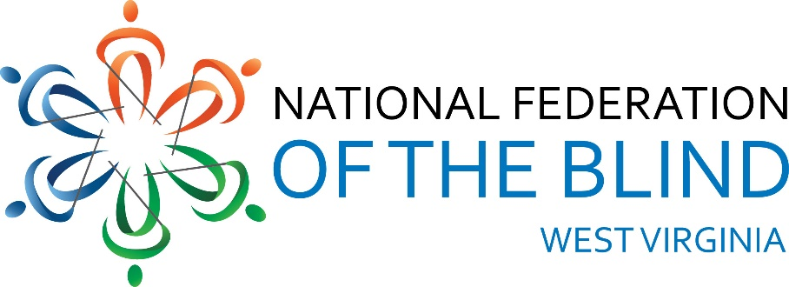
National Federation of the Blind of West Virginia 2024 State Convention
Holiday Inn-University Area, 1188 Pineview Dr.
Morgantown, WV 26505
AGENDA
Thursday, October 31, 2024
3:00 PM Hotel Check-in
3:30 PM Drop off auction items and door
prizes presidential suite #215
5:00 PM Dinner on your own (Bourbon
Room)
7:30 PM NFBWV Board of Directors Meeting
(Bourbon Room): Sheri Koch,
Chair
Friday, November 1, 2024
BLIND COMMUNITY UNITY DAY:
8:00 AM Vendor Booths Setup (Liberi
Section)
8:30 AM Welcome (Montani Semper
Section): Sheri Koch, NFBWV
President
A Moment of Silence for Those
We’ve Lost
Vendor Mini Presentations: 10
Minutes Each
VISIONS: Amanda Udell
WV Assistive Technology System
(WVATS): Doug Cumpston
Jehovah’s Witness (JW.org) Robert
& Geraldine Johnson, Ron & Diane
Barnett
WV Library Commission: Susan
Ward
American Printing House for the
Blind (APH): Lee Huffman &
Jim Sullivan Monarch)
LiveAbility Center for Independent
Living: Annetta Johnson
This & That Gadgets Table:
Demonstrations Provided by Blind
Equipment owners: NFBWV
Members, Other Interested Gadget
Users
10:00 AM BREAK
10:15 AM Explore the Vendor booths (Liberi
Section)
11:30 PM BOX LUNCH: (Montani Semper
Section)
12:30 PM GENERAL SESSION
Organization & Agency Reports:
(Montani Semper Section)
National Federation of the Blind, A
National Review of our Mission and
Impact: Jesse Sherik, National
Representative
12:50 PM National Federation of the Blind of
West Virginia, A State and
Grassroots Perspective on our
Mission and Impact: Sheri Koch,
NFBWV President
1:00 PM WV School for the Deaf and the
Blind: Melanie Hesse, WVSDB Dean
of Students & Wendy Bailey,
Statewide Outreach Specialist for
WVDE
1:20 PM Cabell-Wayne Association of the
Blind: Toni Walls, Executive
Director
1:40 PM Seeing Hand Association for the
Blind: Karen Haught, Executive
Director
2:00 PM LiveAbility Center for Independent
Living, Morgantown: Annetta
Johnson, Administrative Director
2:20 PM American Foundation for the Blind,
Huntington: Aaron Preece,
AccessWorld Editor
in Chief
2:40 PM American Printing House for the
Blind, (APH) Huntington: Lee
Huffman, Low Vision Product
Manager, Product Development
Jim Sullivan, (APH) Director, Social
Enterprise
3:00 PM BREAK
3:15 PM LET’S TALK: West Virginia Division
of Rehabilitation Services
(WVDRS); A Pannel
b Discussion on Services and
Policies: Pisnu Bua-Iam, WVDRS
Director; (Blind Services Staff)
Candice Ward, Assistant Director,
Rachel Hatfield, Rehabilitation
Services Manager 1, Gentry Klein,
Deputy Director, Kevin Maynus,
Rehabilitation Specialist for the
Blind, Tammy Murdock, VISIONS
Manager, NFBWV members, Jesse
Sherik, NFB National
Representative, and other
interested blind stakeholders
5:00 PM Wrap-up and Adjourn
6:15 PM DINNER (Montani Semper Section)
8:00 PM AUCTION: All Things West
Virginia: Marcus Soulsby,
Auctioneer
Saturday, November 2, 2024
8:30 AM GENERAL SESSION: (Montani
Semper Section)
Call to Order, remarks, &
Announcements: Sheri Koch,
NFBWV President
Pledge of Allegiance, Led by
Harold Thomas Rogers, Member at
Large
NFB Pledge: Led by Karen
McDonald
“I pledge to participate
actively in the efforts of
the National Federation
of the Blind; to achieve
equality, opportunity, and
security for the blind; to
support the policies and
programs of the Federation;
and to abide by its
constitution.”
8:35 AM WHAT’S GOING ON AT THE
NATIONAL LEVEL: NFB Report:
Jesse Sherik, National
Representative
9:00 AM WHAT’S GOING ON AT THE LOCAL
LEVEL, NFBWV Report: Sheri
Koch, NFBWV President
9:15 AM FUNDAMENTALS OF SELF-
ADVOCACY: Jesse Sherik,
National Representative
10:15 AM BREAK
10:30 AM TRAINING FOR LIFE AT AN NFB
CENTER: My Experience at the
Louisiana Center for the Blind:
Ahmad Shafi, NFBWV Member at
Large
11:00 AM CHALLENGING INACCESSIBILITY
AT THE UNIVERSITY LEVEL:
Miranda Lacy & Harold Rogers,
WVU MSW Students and NFBWV
Members at Large, & Sheri Koch
facilitating
11:30 AM MY EXPERIENCE AS A TEACHER
OF MORROW: Wendy Bailey
12:00 PM LUNCH
1:30 PM GENERAL SESSION;
Convention Business (Montani
Semper Section)
BUILDING OUR AFFILIATE:
A ROADMAP FOR TODAY AND
TOMORROW; Final Report of the
Committee of the Whole on
Membership Building: Review &
Progress Report: Ed McDonald,
1st Vice-president and President
Members at Large Chapter
RESOLUTIONS: Ed McDonald, Mr.
Whereas
FINANCIAL MATTERS: Garrett
Harris, interim Treasurer
ELECTION OF OFFICERS
CHAPTER REPORTS:
Sightless Workers Guild Chapter
President, Jack Yahnke & Members
at Large Chapter President, Ed
McDonald
OPEN DISCUSSION: Review of Blind
Community Unity Day; Initiatives &
Priorities for the Coming Year:
Ed McDonald. Facilitator
4:30 PM WRAP-UP AND ADJOURN
6:30 PM BANQUET
Master of Ceremonies: Ed
McDonald
Keynote Speaker: Jesse Sherik
Sunday, November 3, 2024
9:00 AM IN MEMORIUM, Remembering
Those We’ve Loved and Lost:
Marla Sewell, Members at Large
(Montani Semper Section)
10:00 AM WRAP-UP, ADJOURN, & CHECK-
OUT
THANKS YOU FOR SHARING YOUR TIME, SPIRIT, AND GREAT IDEA! THE FELLOWSHIP WAS WONDERFUL! BE SAFE GOING HOME.

