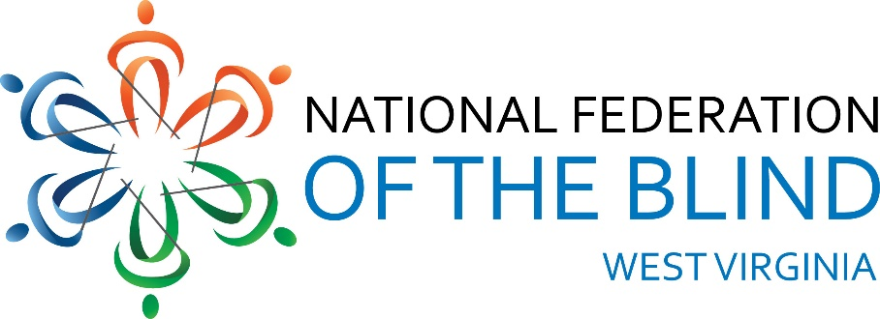
National Federation of the Blind of West Virginia 2024 State Convention
Holiday Inn-University Area, 1188 Pineview Dr.
Morgantown, WV 26505
AGENDA
Thursday, October 31, 2024
3:00 PM Hotel Check-in
3:30 PM Drop off auction items and door prizes presidential suite #215
5:00 PM Dinner on your own (Bourbon Room)
7:30 PM NFBWV Board of Directors Meeting (Bourbon Room): Sheri Koch, Chair
Friday, November 1, 2024
BLIND COMMUNITY UNITY DAY:
8:000 AM Vendor Booths Setup (Liberi Section)
8:30 AM Welcome (Montani Semper Section): Sheri Koch, NFBWV President
A Moment of Silence for Those We’ve Lost
Vendor Mini Presentations: 10 Minutes Each
VISIONS: Amanda Udell
WV Assistive Technology System (WVATS): Doug Cumpston
Jehovah’s Witness (JW.org) Robert & Geraldine Johnson, Ron & Diane
Barnett
WV Library Commission: Susan Ward
American Printing House for the Blind (APH): Lee Huffman and
Jim Sullivan Monarch
LiveAbility Center for Independent Living: Annetta Johnson
This & That Gadgets Table: Demonstrations Provided by Blind Equipment
Owners: NFBWV members, other interested gadget Users
10:00 AM BREAK
10:15 AM Explore the Vendor booths (Liberi Section)
11:30 PM BOX LUNCH (Montani Semper Section)
12:30 PM GENERAL SESSION
Organizations & Agency Reports: (Montani Semper Section)
National Federation of the Blind, A National Review of our Mission and
Impact: Jesse Sherik, National Representative
12:50 PM National Federation of the Blind of West Virginia, A State and
Grassroots Perspective on our Mission and Impact: Sheri Koch, NFBWV
President
1:00 PM WV School for the Deaf and the Blind: Melanie Hesse, WVSDB Dean of
Students and Wendy Bailey, Statewide Outreach Specialist for WVDE
1:20 PM Cabell-Wayne Association of the Blind: Toni Walls, Executive Director
1:40 PM Seeing Hand Association for the Blind: Karen Haught, Executive Director
2:00 PM LiveAbility Center for Independent Living, Morgantown: Annetta Johnson,
Administrative Director
2:20 PM American Foundation for the Blind, Huntington: Aaron Preece,
AccessWorld Editor in Chief
2:40 PM American Printing House for the Blind, Huntington: Lee Huffman, Low
Vision Product Manager, Product Development and Jim Sullivan, Director,
Social Enterprise
3:00 PM BREAK
3:15 PM Let’s Talk: West Virginia Division of Rehabilitation Services (WVDRS); A
Pannel Discussion on Services and Policies: Pisnu Bua-Iam, WVDRS
Director; (Blind Services Staff) Candice Ward, Assistant Director,
Rachel Hatfield, Rehabilitation Services Manager 1, Gentry Klein,
Deputy Director, Kevin Maynus, Rehabilitation Specialist for the
Blind, Tammy Murdock, VISIONS Manager, NFBWV members, Jesse
Sherik, NFB National Representative, and other interested blind
stakeholders
5:00 PM Wrap-up and Adjourn
6:15 PM DINNER (Montani Semper Section)
8:00 PM AUCTION: All Things West Virginian: (Montani Semper Section)
Marcus Soulsby, Auctioneer
Saturday, November 2, 2024
8:30 AM GENERAL SESSION: (Montani Semper Section)
Call to Order, Remarks, & Announcements: Sheri Koch, NFBWV
President Pledge of Allegiance, Led by Harold Thomas Rogers
NFB Pledge, by Karen McDonald
“I pledge to participate actively in the efforts of the National
Federation of the Blind; to achieve equality, opportunity, and
security for the blind; to support the policies and programs
of the Federation; and to abide by its constitution.”
8:35 AM WHAT’S GOING ON AT THE NATIONAL LEVEL, NFB Report: Jesse Sherik,
National Representative
9:00 AM WHAT’S GOING ON AT THE STATE LEVEL, NFBWV Report: Sheri Koch
NFBWV President
9:15 AM FUNDAMENTALS OF SELF-ADVOCACY: Jesse Shirek, National
Representative
10:15 AM BREAK
10:30 AM TRAINING FOR LIFE AT AN NFB CENTER: My Experience at the
Louisiana Center for the Blind: Ahmad Shafi, NFBWV Member
at Large
11:00 AM CHALLENGING INACCESSIBILITY AT THE UNIVERSITY LEVEL: Miranda
Lacy & Harold Rogers, WVU MSW Students and NFBWV Members, and
Facilitated by Sheri Koch
11:30 AM MY EXPERIENCE AS A TEACHER OF TOMORROW: Wendy Bailey
12:00 PM LUNCH
1:30 PM GENERAL SESSION;
Convention Business (Montani Semper Section)
BUILDING OUR AFFILIATE: A ROADMAP FOR TODAY AND TOMORROW;
Final Report of the Committee of the Whole on Membership Building:
Review & Progress Report: Ed McDonald, 1st Vice-president and
President Members at Large Chapter
RESOLUTIONS: Ed McDonald, Mr. Whereas
FINANCIAL MATTERS: Garrett Harris, Interim Treasurer
ELECTION OF OFFICERS
CHAPTER REPORTS: Sightless Workers Guild President, Jack Yahnke
& Members at Large President, Ed McDonald
OPEN DISCUSSION: Review of Blind Community Unity Day; Initiatives &
Priorities for the Coming Year
4:30 PM WRAP-UP AND ADJOURN
6:30 PM BANQUET: Master of Ceremonies: Ed McDonald &
Keynote Speaker: Jesse Sherik
Sunday, November 3, 2024
9:00 AM IN MEMORIUM, Remembering Those We’ve Loved and Lost: Marla
Sewell, Members at Large (Montani Semper Section)
10:00 AM WRAP-UP, ADJOURN, AND CHECK-OUT
THANKS YOU FOR SHARING YOUR TIME, SPIRIT, AND GREAT IDEA! THE FELLOWSHIP WAS WONDERFUL. BE SAFE GOING HOME.

